Let (Name): ________________________________reputation shine! Period: _______ Date: _____________

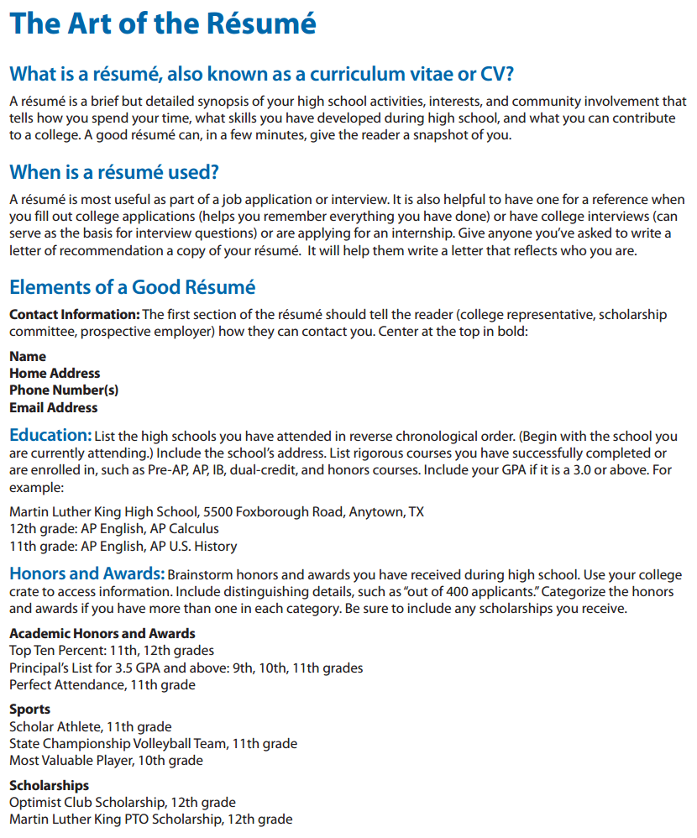

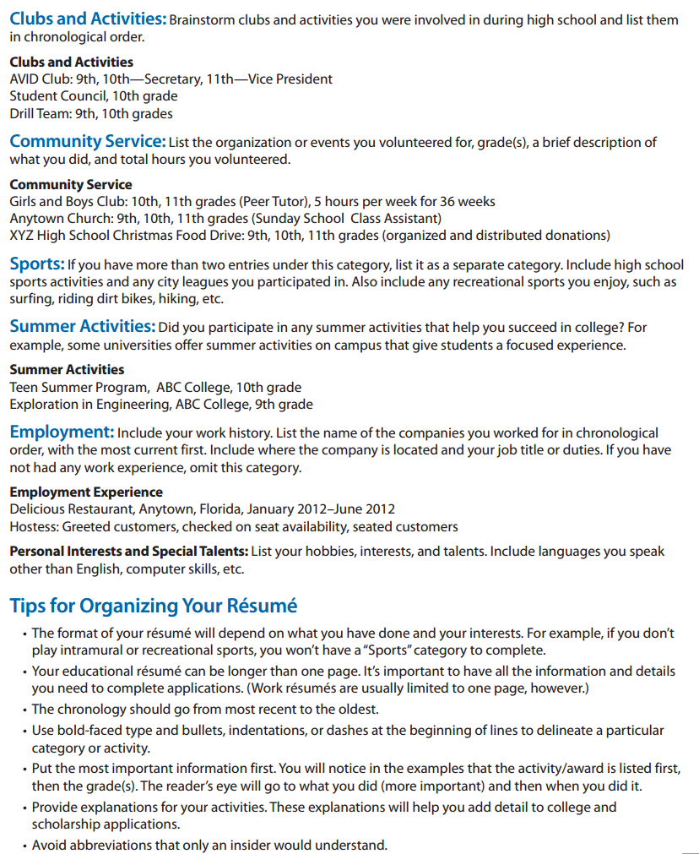

**Sample Resume**

